**Phenotypic characterization of gram-negative bacilli producing extended-spectrum β-lactamases of the CTX-M type isolated from drinking water in plastic bags sold in Cameroon**

Nguepidjo Gilbert1, Tonmeu Douyong Chimène Sandrine1, Kapso Tchouankep Mireille1,2, Djukoué Ingrid1, Ngong Ankiambom Innocent1, Nguwoh Philippe Salomon1, Lele Mbomgni Samuel1, Baiye William1, Koji Ernest2, Ndzana Joseph René1, Gonsu Kamga Hortense3

1Department of Public Health, Faculty of Health and Life Sciences, Distant Production House, University (DPHU), Rwanda

2Laboratory of Human Biology and Health, Department of Animal Biology, Faculty of Sciences, University of Douala, Cameroon.

3Laboratory of Bacteriology, Center University Teaching Hospital of Yaounde, Faculty of Medcine and Biomedical Sciences, University of Yaounde I, Cameroon

Email: mireillekapso@yahoo.fr Tel: (00237) 696711733/672 779 664

**Abstract**

**Introduction:**Drinking water packaged in plastic bags is very popular with people because of its affordable cost, its refreshing character, its ease of consumption and its accessibility. However, the dubious quality and the lack of hygiene noted around its sale, raise fears of the risk of waterborne infection.

**Methodology :**Our descriptive cross-sectional study took place over a period of 5 months, from March to July 2014, a total of 520 plastic water bags were purchased from different suppliers in the ten regions of Cameroon. The membrane filtration method was used and the cultures were made on VRBLA (Violet Red Bile Lactose Agar) medium.

**Results:** After analyzing these 520 sachets of 28 different brands, we obtained the following results: Twenty brands (71%) presented a positive culture and therefore unsuitable for consumption; Eight brands showed a sterile culture and 58.65% of positive cultures, therefore not satisfactory. The regions with the highest number of isolates were those of the North and the Far North with 20.74% each. We also noted that 58.50% of isolated germs were total coliforms. We also noted that 35% of isolated germs gave a positive result to the synergy test and a prevalence of 7% for CTX-M type ESBLs. In addition, ESBL presented 100% resistance to the following antibiotics: Cefepime, Cefotaxime, Ceftriaxone and Ticarcillin.

**Conclusion:**Most of the water in plastic bags sold in Cameroon was unfit for consumption because it contained Gram-negative bacilli.

**Key words :**ESBL, CTX-M, Resistance, Drinking water in sachets, bacteriological quality, regions of Cameroon.

**Introduction**

Extended-spectrum beta-lactamase-producing Enterobacteriaceae have become a real public health problem worldwide (Akoueteviet al., 2017). Until the end of the 1990s, these bacteria were found overwhelmingly in healthcare structures, in which they spread in an epidemic mode. These phenomena have motivated the implementation of successful hospital hygiene programs (Njall et al., 2013). The situation has been turned upside down by the spread of multi-resistant bacteria in the "community" environment (outside the healthcare system) in which hospital hygiene programs cannot be transposed. The community diffusion of Broad Spectrum β-Lactamase-producing Enterobacteriaceae (ESBLE) is thus particularly worrying. Until the end of the 1990s, ESBLs were mainly produced by the genera Enterobacter and Klebsiella; species responsible for hospital epidemics but not resident in the intestinal microbiota of healthy subjects. These ESBLs were mainly derivatives of beta-lactamases with a narrower hydrolysis spectrum: Temoneira (TEM) and Sulfhydryl Variables (SHV) (Mohammed et al., 2017).

In recent years, Enterobacteriaceae have moved from the hospital to the community and into the environment (Akoueteviet al., 2017). Indeed, the role of water pollution as the main reservoir for ESBL diffusion has been well documented.

The consumption of contaminated water containing pathogenic microorganisms is the cause of many diseases. However, because of their affordable cost, their refreshing character and the ease of obtaining them, water in plastic bags is often iced and offered to consumers in different parts of the ten regions of Cameroon in often precarious conditions. The lack of hygiene and the questionable quality observed around the sale of this water mean that the risks of waterborne infections are to be considered and remain frequent (Benajiba et al., 2013; Santsa Nguefack et al., 2018) . In this study, we set out to assess the possible presence of microorganisms that could have consequences on human health and give an idea of ​​the hygienic quality of drinking water in sachets sold on Cameroonian markets. More specifically, it was a question of estimating the bacterial load of these waters, isolating and identifying any bacteria contained in these waters and carrying out a study of the sensitivity to antibiotics of the bacterial strains identified.

1. **Methodology**
   1. **Sampling and isolation of bacteria**

The water sachets were collected according to the brands in the strong gathering points (markets, stations, crossroads, schools and universities, etc.) in the main towns of the ten regions of Cameroon. The water sachets were labeled and then transported between 4°C and 8°C in coolers to the laboratory. The microbiological analyzes were carried out in the bacteriology laboratory of the Center for Analysis, Testing and Industrial Metrology (CAEMI) of the Ministry of Mines, Industry and Technological Development (MINMIDT) and in the bacteriology laboratory of the University Hospital Center (CHU) of Yaoundé.

The estimation of the health risks associated with the consumption of drinking water in sachets came down during this study to looking for different germs such as Escherichia coli, Salmonella, Enterobacter, Klebsiella pneumoniae. For this several culture media were used, particularly the "Violet Red Bile Lactose Agar" (VRBLA) and Mueller Hinton Agar (MH).After rinsing the sachet under a jet of water to rid it of any impurities, shake vigorously to homogenize the contents. The method used is that of membrane filtration. The filter membranes used were made of cellulose ester, with a porosity of 0.45 µm and a diameter of 55 mm (Rodier, 2009). After filtration, the membrane is gently placed on the VRBLA culture medium prepared extemporaneously. Incubation was carried out at 37°C for the search for total coliforms and at 44°C for the search for faecal coliforms for 24 to 48 h. The counting of the colonies was done, slides for Gram staining of the different colonies were made, and finally the different germs were aliquoted and stored at -20°C in the strain bank of the bacteriology laboratory of the University Hospital Center (CHU) of Yaoundé. The 3rd step consisted in the biochemical identification by the API 20E Gallery which is a standardized system for the identification of Enterobacteriaceae and other Gram-negative bacilli.

Packaging, conditioning and conservation most frequently lead to a modification of microorganisms, these viable but stressed cells require a cell repair step. The revivification was carried out in the diluent (peptone water or peptone salt) to which were added different molecules (pyruvate, acetate, citrate or glutamate), amino acids (3-betaine or proline), osmoprotectors (glycerol), sugars (lactose, sucrose or glucose), different ions (Na2HPO4, KH2PO4, MgSO4), an enzyme (catalase) and yeast extract (Garry, 2000). For this, 1ml of bacterial suspension after heat treatment is added to 9 ml of revivification medium and the tubes are incubated in an oven between 30 or 37°C for 30 to 60 minutes (Garry, 2000).

* 1. **Realization of the Antibiogram**

The inoculum was prepared from a bacterial strain of 18 to 24 hours and standardized to make it possible to obtain contiguous colonies after culture on the Mueller Hinton (MH). At least three different colonies are picked and introduced into a tube containing 10 ml of sterile distilled water. Then, the inoculum is adjusted to the standard 0.5 Mac Farland (108 CFU/ml). Seeding was done by flooding the entire surface of the agar with 3 to 5 ml of bacterial suspension. After having carried out complete rotations to ensure a good distribution of the suspension, the petri dishes are incubated in an oven at 37°C for 10 to 15 minutes for drying, then the discs are placed on the agar. 30 mm apart using an automatic applicator and the dishes are acclimatized at room temperature for 30 minutesare. The antibiotics used were:

* **Beta-lactams**: Tircacillin (TIC), Amoxicillin + Clavulanic Acid (AMC), Cefotaxime (CTX), Cefoxitin (FOX), Ceftazidime (CAZ), Cefepime (FEP), Aztreonam (ATM), Ceftrixone;
* **Quinolones and fluoroquinolones**: Ofloxacin (OFX); Ciprofloxacin (CIP), Nalidixic acid (NA);
* **Aminosides**: Gentamicin (GM); Kanamycin (K); Amikacin(AN);
* **Fosfomycin**(FOS),
* **Sulfamethoxazole-trimethoprim**(SXT).

The discs were placed in such a way that possible images of synergy were visible between the Amoxicillin + Clavulanic acid disc, the 3rd Generation Cephalosporin discs (C3G) and the C4G discs.Petri dishes were incubated in an oven for 18-24 hours. Using a caliper, we measured the inhibition diameters of the different antibiotics tested. The results were recorded on the antibiogram sheet. Based on diameter, we categorized antibiotics into: Susceptible (S), Resistant (R), and Intermediate Sensitivity (I).

* 1. **ESBL synergy test**

The synergy test is a test to confirm the presence of ESBL. Using a colony taken from a previously inoculated blood agar medium, a Mac Farland 0.5 suspension is prepared and is used to inoculate a Mueller-Hinton medium. It is on this medium that 3 to 4 discs of antibiotics (C3G; C4G) are deposited, 30 mm apart: around a disc of amoxicillin and clavulanic acid (respectively 20 and 10 μg). The distance between the edge of the discs is previously determined to optimize the sensitivity of the test. After 18 – 24 hours of incubation at 37°C, the result is declared positive if there is an increase in the zone of inhibition around the discs containing ceftriaxone, ceftazidime, cefepime, aztreonam in the direction of the disc carrier of clavulanic acid. In d' In other words, it is the increase in the zone of inhibition obtained for a cephalosporin in the presence of clavulanic acid, compared to the zone of inhibition of a cephalosporin alone, which indicates the presence of an ESBL. A positive synergy test therefore gives a characteristic “Champagne cork” image.

Internal quality control testing was performed to verify the sterility, fertility and reliability of the culture media, antibiotic discs and gallery using a susceptible inbred strain (Escherichia coli ATCC35218) obtained from the bacteriology laboratory of the Yaoundé University Hospital. The antibiogram of the strains is carried out at the same time as that of the strains to be studied. The data obtained were processed using the Excel spreadsheet of the Microsoft program, version 2010 and SPSS 17.0 software.

1. **Results**
   1. **Qualitative and quantitative characterization of isolated germs**

During this study, 28 different brands of water in plastic bags were identified throughout the country, of which 8 brands (29%) showed a sterile culture and 20 brands (71%) a positive culture (figure 1A). Of the culture-positive samples, 10 brands (35.71%) presented after culture a number of CFU > 200 number beyond the detection threshold of the method, 10 other brands (35.71%) presented after culture a number of colonies <200. In terms of water sachets analyzed, positive cultures are noted in 305 sachets (59%) and negative cultures in 215 water sachets (41%) (FIG. 1B).

**B**

**Figure 1 :** Distribution of brands according to culture results (A) and level of contamination by bacteria (A)

13 species of bacteria were isolated from bagged water: Escherichia coli, Salmonella typhi, Providencia alcalifasciens, Proteus mirabilis, Klebsiella pneumoniae, Salmonalla salmonicida, Enterobacter cloacae, Salmonella maltophilia, Pseudomonas aeruginosa, Burkholderia cepacia, Acinetobacter baumannii, Pasteurella pneumotropica, and Pseudomonas luteola. Pseudomonas sp. and E. coli are most abundant in culture-positive samples. The isolated germs were mainly non-fermentative bacteria: Pseudomonas (144 isolates; i.e. 29.90%, and Escherichia coli (100 isolates; i.e. 20.75% (Figure 2A). The majority of isolated germs were non-enterobacteriaceae, 261 germs isolated (54.15%) and enterobacteriaceae present at 46% (FIG. 2B).The isolated germs were mainly total coliforms 282 isolated germs (59%) (FIG. 2C).

**AT**

**VS**

**Figure 2:**Variations of germs according to abundance (A), Enterobacteriaceae (B) and Coliforms (C)

* 1. **Sensitivity to the antibiotics tested**

The performance of antibiograms made it possible to obtain resistance phenotypes as well as synergistic mechanisms. Of the 16 antibiotics tested, the ESBL germs show 100% resistance to the following antibiotics: Cefepime, Cefotaxime, Ceftriaxone, Ticarcillin. In addition, 50 germs or 29.60% are resistant to nalidixic acid, Amoxicillin + Clavulanic acid, Gentamicin; 112 germs or 66.30% are resistant to Aztreonam; 122 germs or 72.2% are resistant to Ceftazydime; 35 germs or 20.71% are resistant to Ciprofloxacin; 147 germs or 87.0% are resistant to Cotrimoxazole and 22 germs or 13.0% are resistant to Ofloxacin (FIG. 3).

Antibiotics

**Figure 3:**Variation in the resistance of germs isolated from water in sachets to antibiotics

* 1. **Characterization of ESBL synergies**

A positive synergy test therefore gives a characteristic “Champagne cork” image (Hilde De Boeck et al., 2010)

**Description of the image :**3 to 4 discs of antibiotics (C3G; C4G) arranged around a disc of amoxicillin and clavulanic acid (in the center). After one night in an oven, the result is declared positive if there is an increase in the zone of inhibition around the discs containing ceftriaxone, ceftazidime, cefepime, aztreonam towards the disc carrying clavulanic acid. In other words, it is the increase in the zone of inhibition obtained for a cephalosporin in the presence of clavulanic acid, compared to the zone of inhibition of a cephalosporin alone, which indicates the presence of a ESBL. A positive synergy test therefore gives a characteristic “Champagne cork” image.

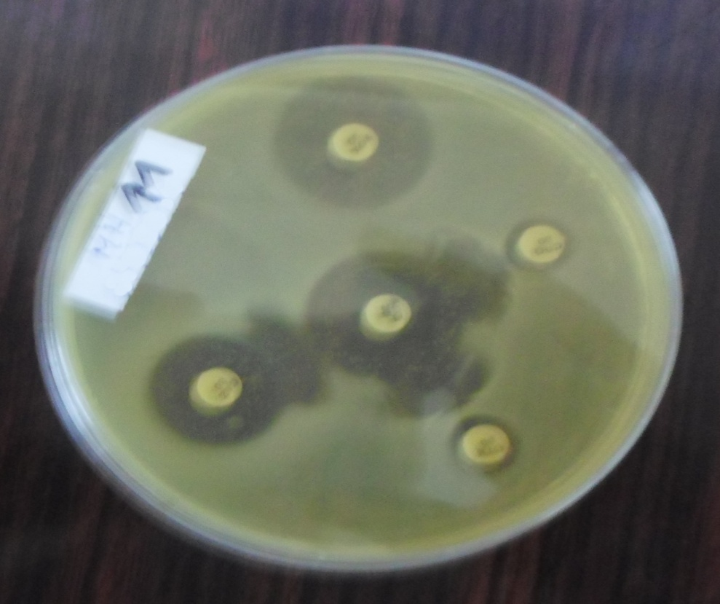

**Figure 4**: Image of the “champagne cork”

Of the 482 isolated germs, we have 169 which are ESBL (35%). Among these isolated ESBL enterobacteriaceae, some showed a CTX-M phenotype (12.7%).ESBLs are class A β-lactamases which take their name from their preferential hydrolysis of cefotaxime compared to ceftazidime. They do not hydrolyze either cephamycins or carbapenems. CTX-M type ESBLs are resistant to cefotaxime and sensitive to ceftazidime (Lepeule, 2012).

**Figure 6:** Synergy and distribution of Enterobacteriaceae according to the CTX-M phenotype

1. **Discussion**

Microbiological analysis enabled us to isolate 482 strains of microorganisms. The relatively high prevalence (59%) of contamination by pathogenic germs in water in sachets suggests questionable hygiene in the places where these waters in sachets are manufactured (source of water, bagging equipment, health of employees, method of opening the bagging papers) because the presence of thermo-tolerant coliforms in drinking water should raise suspicion of insufficient treatment, post-treatment contamination (WHO, 2017). Based on this fact, post-treatment contamination mainly linked to a lack of hygiene during the packaging and sale of water in plastic bags would be a large part of the origin of this contamination. This prevalence relatively similar to the results of Ndiaye (2008) in the waters of 4 municipalities in Abidjan (in Côte d'Ivoire) and to those of Modou et al. (2021) who found 83% contamination in bagged water consumed in Dakar, Senegal in 2021. Most of the germs isolated were non-enterobacteriaceae (54.15%). This figure shows that these waters are not free of microorganisms, which is synonymous with environmental contamination (Pseudomonas: 29.90%). According to the WHO (WHO, 2017), the quality standards for water for human consumption set 0 CFU/100 ml of water for all faecal contamination indicator bacteria. Most of the germs isolated were non-enterobacteriaceae (54.15%). This figure shows that these waters are not free of microorganisms, which is synonymous with environmental contamination (Pseudomonas: 29.90%). According to the WHO (WHO, 2017), the quality standards for water for human consumption set 0 CFU/100 ml of water for all faecal contamination indicator bacteria. Most of the germs isolated were non-enterobacteriaceae (54.15%). This figure shows that these waters are not free of microorganisms, which is synonymous with environmental contamination (Pseudomonas: 29.90%). According to the WHO (WHO, 2017), the quality standards for water for human consumption set 0 CFU/100 ml of water for all faecal contamination indicator bacteria.

One hundred sixty-nine isolates (35%) were confirmed as ESBL producers. This percentage is higher than that found by De Boeck Hilde in 2012 in Kinshasa-Democratic Republic of Congo which was eight isolates (5.3%) in 101 sachets of water analyzed. These alarming results could be explained by the fact that the reservoir is human, these bacteria belong to the cutaneous flora, drawing attention to the personal hygiene of the handlers of these waters in sachets. Twelve isolates (7%) of ESBL exhibited a CTX-M phenotype. The germs tested show resistance to the following antibiotics: Cefepime, Cefotaxime, Ceftriaxone, Ticarcillin. These resistances would be linked to the lack of hygiene in the places where the water is produced, to the anarchic use of antibiotics.

***Escherichia coli*28 North**, tested resistant to Ticarcillin could be a hospital strain returned to the environment. That is to say a strain which has already come into contact with these families of antibiotics before being found in the environment or a strain which has undergone mutations because of the unfavorable conditions of the water in which it was grown; which constitutes a real public health problem.

**Conclusion**

This study made it possible to highlight the existence of pathogenic germs of faecal and environmental contamination. The bacterial load is estimated at 67 CFU/ml on average. The search for contaminants was positive and more than half of the samples analyzed presented a positive culture, to the target germs of the study and to other germs supposed to be absent in drinking water. The following germs have been isolated and identified Escherichia coli, Salmonella typhi, Providencia alcalifasciens, Proteus mirabilis, Klebsiella pneumoniae, Salmonalla salmonicida, Enterobacter cloacae, Salmonella maltophilia, Pseudomonas aeruginosa, Burkholderia cepacia, Acinetobacter baumannii, Pasteurella pneumotropica, Pseudomonas luteola. All these isolated germs showed resistance to the following antibiotics: Cefepime, Cefotaxime, Ceftriaxone, Ticarcillin. In view of these results, these waters in sachets are therefore unfit for human consumption and it is necessary to warn consumers of the health risks involved. In addition, this emergence of bacteria that produce ESBL and other community-associated infections constitutes a public threat, particularly in low-resource countries where surveillance is not optimal and empirical treatment for invasive infections often includes cephalosporins of third generation. The problem of increased bacterial resistance to antibiotics is and will continue to be topical in the coming years. these waters in sachets are therefore unfit for human consumption and it is necessary to warn consumers of the health risks involved. In addition, this emergence of bacteria that produce ESBL and other community-associated infections constitutes a public threat, particularly in low-resource countries where surveillance is not optimal and empirical treatment for invasive infections often includes cephalosporins of third generation. The problem of increased bacterial resistance to antibiotics is and will continue to be topical in the coming years. these waters in sachets are therefore unfit for human consumption and it is necessary to warn consumers of the health risks involved. In addition, this emergence of bacteria that produce ESBL and other community-associated infections constitutes a public threat, particularly in low-resource countries where surveillance is not optimal and empirical treatment for invasive infections often includes cephalosporins of third generation. The problem of increased bacterial resistance to antibiotics is and will continue to be topical in the coming years. poses a public threat especially in low-resource countries where surveillance is suboptimal and empirical treatment for invasive infections often includes third-generation cephalosporins. The problem of increased bacterial resistance to antibiotics is and will continue to be topical in the coming years. poses a public threat especially in low-resource countries where surveillance is suboptimal and empirical treatment for invasive infections often includes third-generation cephalosporins. The problem of increased bacterial resistance to antibiotics is and will continue to be topical in the coming years.

**Acknowledgment**

We mainly thank the head of the bacteriology laboratory of the Center for Analysis, Testing and Industrial Metrology (CAEMI) of the Ministry of Mines, Industry and Technological Development (MINMIDT) for his agreement to handle our samples of waters. We also thank the head of the bacteriology laboratory department of the University Hospital Center (CHU) of Yaoundé for having accepted that the study of the sensitivity of our isolated germs be evaluated in this department.

**References**

# Akouétévi GT, Bouraïma D., Simplice DK, Ségla T., Yaovi A., Comlan de Souza (2017). Prevalence of extended-spectrum beta-lactamase-producing Enterobacteriaceae strains isolated in Togo and their sensitivity to antibiotics. International Journal of Biological and Chemical Sciences. Vol 11 N°3.DOI:[10.4314/ijbcs.v11i3.19](https://doi.org/10.4314/ijbcs.v11i3.19)

Anna Ndiaye (2008).Bacteriological study of drinking water sold in sachets in four municipalities of Abidjan. Pharmacy Doctorate Thesis (166 pages). Faculty of Medicine, Pharmacy and Odonto-Stomatology of UNIVERSITE DE BAMAKO

Benajib MH, Saoud Y., Lamribah A., Ahrikat M., Amajoud N. and Ouled-Zian O. (2013).Evaluation of the microbial quality of groundwater in Martil, Morocco. Review of Water Sciences 26 (3): 223-233.

De Boeck H., Miwanda B., Lunguya-Metila O., Muyembe-Tamfum JJ, Stobberingh E., Glupczynski Y. and Jacobs J. (2012).Positive Enterobacteriaceae Isolates in Drinking Water. EMERGING INFECTIOUS DISEASES. Vol 18 (6): 1019 – 1020must:[10.3201/eid1806.111214](https://dx.doi.org/10.3201%2Feid1806.111214)

Garry, P. (2000).Practical recommendations for the resuscitation of stressed microorganisms with a view to their detection and counting, ACTIA program 96-16, p257-264

Modou Dieng, Janvier Kindossi, Noumbé Diop, Mbaye Mbengue (2021). Quality of drinking water packaged in sachets sold in the Dakar region of Senegal. European Scientific Institute (ESI) 17 (21): 104

# Epidemiological profile of uropathogenic extended-spectrum beta-lactamase-producing Enterobacteriaceae

# Epidemiological profile of uropathogenic extended-spectrum beta-lactamase-producing Enterobacteriaceae

# Epidemiological profile of uropathogenic extended-spectrum beta-lactamase-producing Enterobacteriaceae

# Epidemiological profile of uropathogenic extended-spectrum beta-lactamase-producing Enterobacteriaceae

Mohammed S., Khalid L. and Lhoussaine L. (2017).Epidemiological profile of uropathogenic enterobacteriaceae producing extended-spectrum beta-lactamases. The Pan African Medical Journal; Flight 28:29

Njall C., Adiogo D., Bita A., Ateba N., Sume G, Kollo B., Binam F., Tchoua R. (2013). Bacterial ecology of nosocomial infection in the intensive care unit of Laquintinie hospital in Douala, Cameroon. PAMJ. Vol 14 N°140 10.11604/pamd

WHO (2017).Quality guidelines for drinking water: 4th ed. incorporating the first addendum [Guidelines for drinking-water quality: 4th ed. incorporating first addendum] ISBN 978-92-4-254995-9

Lepeule R, Ruppe E, Le P, Massias L, Chau F, Nucci A. (2012). Cefoxitinas an alternative to carbapenems in a murine model of urinary tract infection due to Escherichia coli harboring CTX-M-15-type extended-spectrum beta-lactamase.Antimicrob Agents Chemother;3:1376-81

Rodier J., Legube B. and Merlet N. (2009):Water analysis-9th edition, Paris: Dunod-1579p.

Santsa Nguefack CV, Ndjouenkeu R. and Ngassoum MB (2018).Pollution of water for human consumption and short-term health risks: Case of the Menoua watershed (Western Cameroon). European Scientific Journal 14(3): 96-117.